Parth Babbar

Different Banking Services

Introduction:
The digital revolution of the banking sector has fundamentally altered how financial services are supplied and consumed in the United States. Traditional banking techniques are being augmented, if not replaced, by internet banking services, mobile banking applications, and voice banking services as technology advances. These technologies provide exceptional ease, efficiency, and accessibility, allowing clients to manage their accounts from nearly anywhere and at any time. This study examines the environment of various digital banking services, including their features, benefits, problems, and the most recent statistics, to offer a full knowledge of their influence on the US financial system.
Online Banking Services:
Introduction:
Online banking has changed the way people in the United States handle their finances. Financial institutions embrace digital technology and provide a variety of online services that improve convenience, efficiency, and accessibility. Online banking, often known as internet or online banking, allows clients to monitor account balances, transfer payments, pay bills, and manage accounts without having to visit a real bank office.
Key Features:
- Account Management: Customers may see their account balances, transaction history, and download account statements.
- Funds Transfer: The capacity to move money between accounts within the same bank and across banks, including interbank transactions.
- Bill Payment: Customers may set up and pay regular bills, such as utility and credit card bills, online.
- Mobile Deposits: Deposit checks utilising a smartphone camera and online banking systems.
- Loan Applications: You may apply for personal loans, mortgages, and other credit products online.
- Investment Services: Manage investment accounts, purchase and sell assets, and obtain financial advice.
- Customer Service: Contact help via chat, email, or secure messaging.
Benefits:
- Convenience: Customers may access their accounts and do transactions from any location with an internet connection, at any time.
- Efficiency: Online banking reduces the need for real bank visits, allowing for rapid and uncomplicated financial management.
- Cost Savings: Reducing reliance on paper statements and in-person services allows banks to save operational expenses while also providing free or low-cost services to clients.
- Real-Time Monitoring: With instant access to account information, users can keep track of their funds in real time.
- Enhanced Security: Multi-factor authentication, encryption, and other security measures prevent fraud and unauthorised access.
Challenges:
- Cybersecurity Risks: Online banking systems are prone to hacking, phishing, and other cyber threats, which increase the risk of cyber-attacks and fraud.
- Technical Issues: Downtime, software difficulties, and network issues can all impede access to online banking services.
- Digital Divide: Not all clients have access to the internet or feel comfortable utilising digital banking services.
- Privacy Concerns: Customers may be concerned about the privacy of their financial information and data security.
Solutions:
- Improved Security: To reduce cybersecurity threats, banks are investing in sophisticated security technologies such as biometric identification, encryption, and AI-powered fraud detection.
- Technical assistance and Infrastructure Upgrades: Financial institutions are improving their IT infrastructure and providing strong technical assistance in order to handle technological difficulties as quickly as possible.
- Bridging the Digital Divide: Banks are providing education and tools to assist less tech-savvy consumers in accessing and using online banking services. They are also aiming to increase internet connectivity in underserved communities.
- Enhanced Privacy Protections: Enforcing stringent data protection regulations and clear privacy procedures to allay client concerns regarding their financial information.
Banking Providers:
- Chase Bank: Provides a complete online banking platform with sophisticated mobile app functionality.
- Bank of America: Recognised for its user-friendly online banking interface and diverse variety of services.
- Wells Fargo: Offers a wide range of online banking services, such as mobile deposits and bill payments.
- Citi Bank: Provides excellent online banking facilities and robust security safeguards.
- Ally Bank: This online-only bank offers attractive interest rates and fee-free banking services.
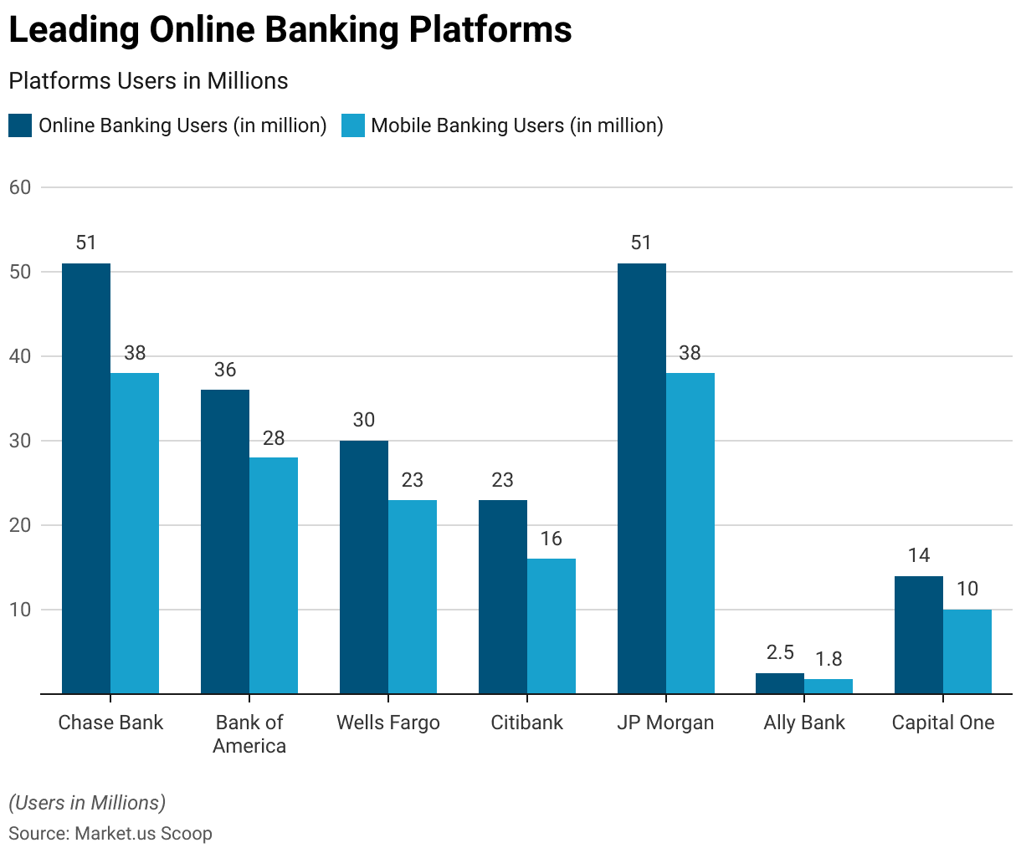
Future Trends:
- Enhanced Security Measures: Biometric authentication, AI-powered fraud detection, and blockchain technology will all be implemented.
- Personalized Services: The use of data analytics and artificial intelligence to provide individualised financial advise and services.
- Integration with Fintech: Banks and fintech companies collaborate to develop innovative products.
- Expansion of Digital Wallets: The rise of systems such as Apple Pay, Google Wallet, and PayPal.
- Sustainability Initiatives: Implementing eco-friendly practices and paperless banking.
- Voice and Chatbot Banking: Using voice assistants and chatbots to connect with customers.
- Open financial: Using open APIs to better financial services.
Statistics:
- As of 2023, around 80% of US adults utilise internet banking services.
- Younger generations, notably Millennials and Generation Z, are the most active consumers of internet banking.
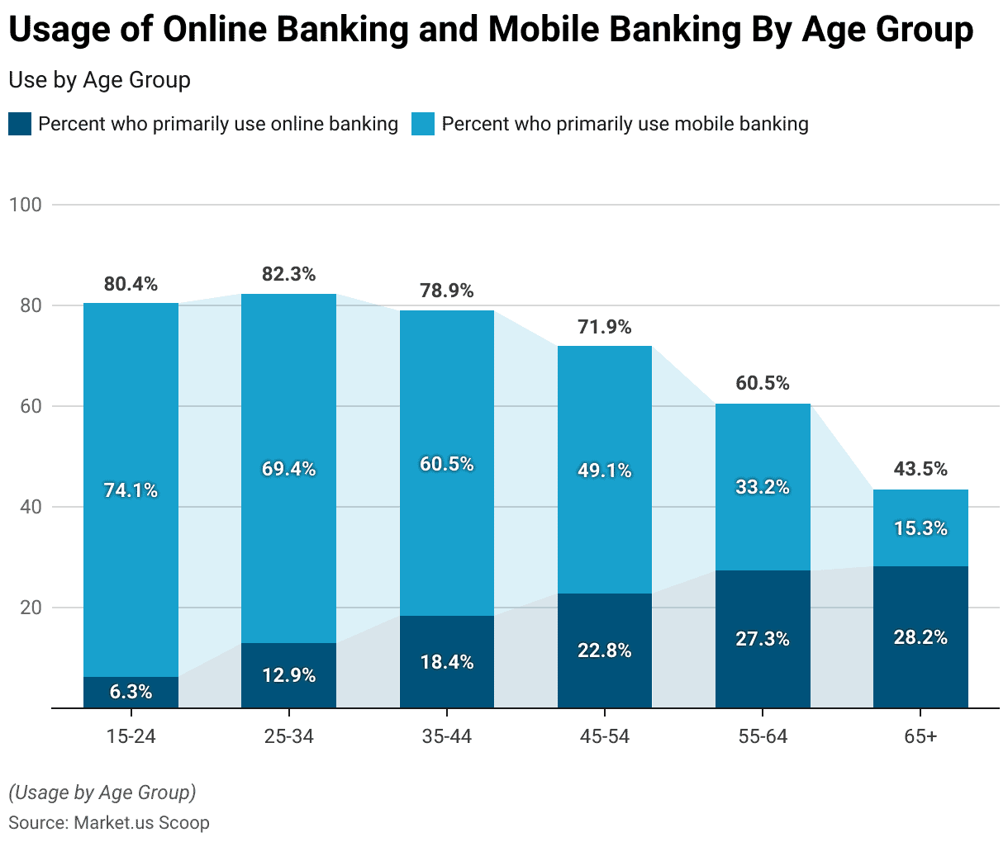
- According to surveys, around 85% of online banking consumers are very satisfied with their digital banking experience.
- Approximately 60% of consumers are concerned about the security of their online banking information.
Conclusion:
Online banking is essential to the US financial environment, helping both customers and institutions. Despite issues such as cybersecurity and digital access limitations, continued technological improvements indicate a brighter banking future. As use increases, internet banking affects US financial services, adapting to meet client demands for safe, convenient, and efficient banking.
Mobile Banking Services:
Introduction:
Mobile banking has transformed financial management in the United States, bringing unparalleled convenience and accessibility. This presentation digs into the current state of mobile banking, including crucial facts, future possibilities, and solutions to existing difficulties. Mobile banking uses dedicated apps on smartphones or tablets, allowing clients to conduct a wide range of financial activities from anywhere.
Key Features:
- Smartphone Deposits: Deposit checks easily by shooting images using the smartphone app, reducing the requirement for actual trips to a bank office.
- Account Management: Monitor balances, check transaction history, and manage numerous accounts from a single mobile platform.
- Cash move: With mobile banking, you may easily move cash between accounts within the same bank or send money to others.
- Bill Payment: Make bill payments easier with the mobile app, assuring prompt settlement of utility bills, credit card payments, and more.
- Alerts and Notifications: Receive real-time alerts and notifications about account activity, which improves security and provides peace of mind.
- ATM Locator: Use the mobile banking app to quickly locate local ATMs and branches, making it easier to access cash and banking services while on the road.
Benefits:
- Accessibility: You can conveniently access financial services while on the go, ensuring that your banking needs are addressed at any time and from any location.
- Real-Time Transactions: Get instant alerts on account activity, providing transparency and prompt financial decisions.
- User-Friendly: Use intuitive interfaces intended for simplicity of use, making banking chores simple and uncomplicated.
- Enhanced Security: Take use of modern security features such as biometric authentication and secure login choices, which provide strong protection of user data and transactions.
Challenges:
- Security Concerns: Mobile devices are vulnerable to hackers and viruses, posing threats to user data and financial transactions.
- Connectivity Issues: Relying on a consistent internet connection for flawless mobile banking experiences can be difficult, particularly in places with weak connectivity.
- User Experience Variability: The quality of user experience differs greatly amongst banking applications, affecting consumer happiness and usability.
Solutions:
- Increased Security: To reduce cyber risks and secure user information, use strong security measures such as encryption, biometric authentication, and continuous transaction monitoring.
- Improved access Solutions: Create offline capabilities and optimise app performance to lessen dependency on continual internet access, resulting in a more seamless user experience under varying network circumstances.
- Standardized User Interfaces: Create industry standards for intuitive and uniform user interfaces across banking apps, which will improve usability and reduce user dissatisfaction.
Future Trends:
- Integration of Emerging Technologies: Mobile banking will use AI and machine learning to provide personalised financial insights and predictive analytics.
- Improved Customer Experience: Banks intend to improve user interfaces and incorporate tools such as voice banking and augmented reality to help with financial planning.
- Service Expansion: Beyond standard duties, mobile banking will offer sophisticated services such as wealth management and personalised investment advice.
- AI-driven Personalisation: Advancements in artificial intelligence will allow banks to provide highly specialised banking experiences, ranging from customised product offers to personalised financial advice
- Mobile Wallet Integration: Mobile banking apps will work seamlessly with mobile wallets, allowing for more efficient payments and collaborations with retailers and service providers.
- Blockchain Revolution: Blockchain technology will revolutionise mobile banking by enabling safe, transparent, and efficient transaction processing.
Banking Providers:
- Traditional Banks: Major institutions such as Bank of America, Wells Fargo, JPMorgan Chase, Citibank, and United States Bank have powerful mobile banking apps.
- Online Banks: Examples of online and mobile banking providers are Ally Bank, Capital One 360, and Discover Bank.
- Credit Unions: Navy Federal Credit Union and PenFed provide mobile banking to its members.
- Fintech Companies: PayPal, Square (Cash App), and Venmo provide mobile banking through their applications.
Statistics:
- As of 2023, roughly 72% of US adults utilise mobile banking on a regular basis.
- The highest adoption rates are among millennials and Generation Z, with more than 85% utilising mobile banking apps.
- The number of mobile banking customers is expected to reach 217 million by 2025.
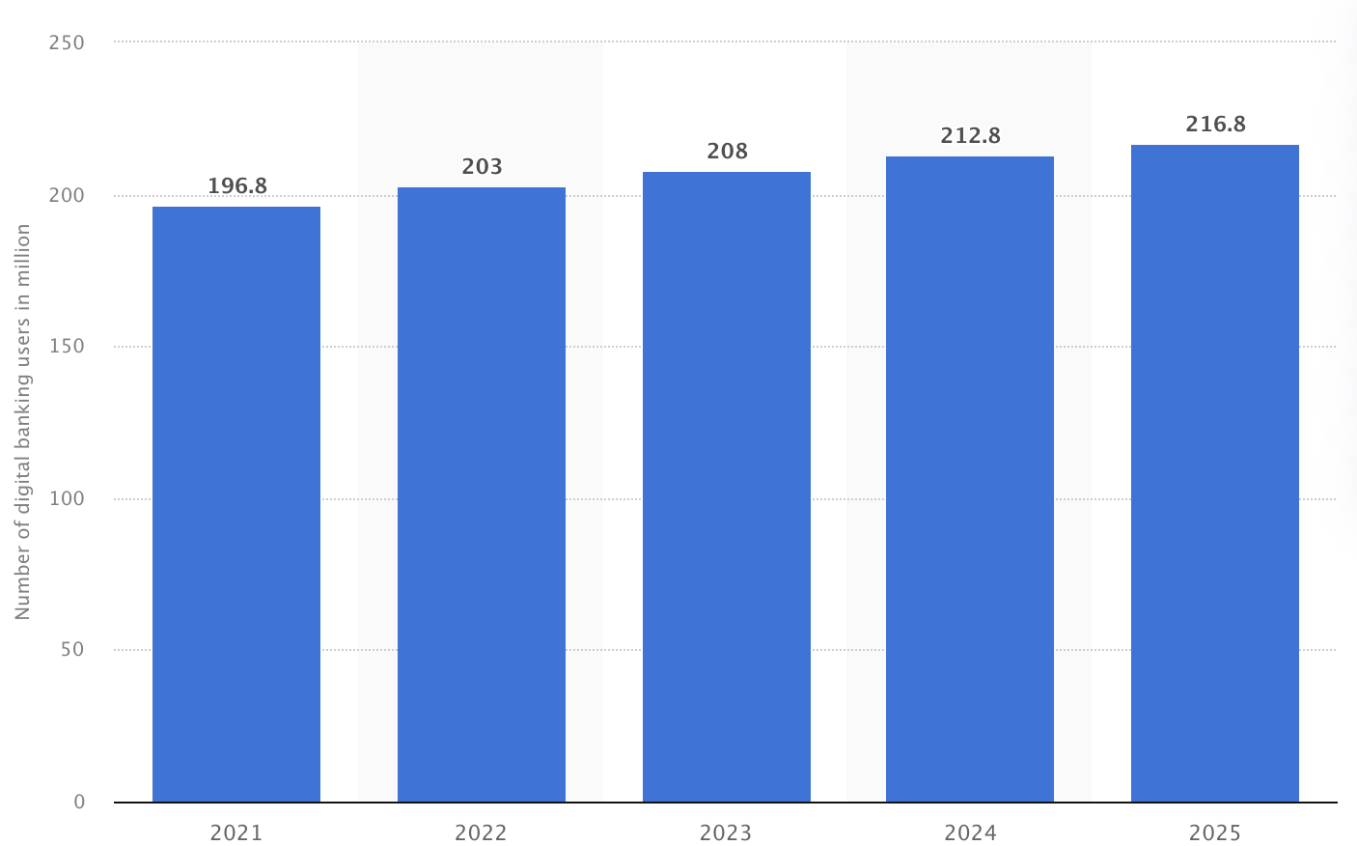
- Losses from mobile banking fraud are expected to total $1.8 billion by 2023.
Conclusion:
Mobile banking services in the United States have altered the way people handle their finances, providing unparalleled ease and accessibility. As technology advances, mobile banking is positioned to expand its capabilities, giving customers with more personalised and secure financial transactions.
Voice Banking Services:
Introduction:
Voice banking services use cutting-edge voice recognition technology, allowing clients to complete a range of financial transactions and queries using voice commands. This article provides an in-depth review of voice banking in the United States, including its existing capabilities, benefits, difficulties, use data, future potential, and possible remedies. Voice banking, which uses virtual assistants like Amazon Alexa, Google Assistant, and Apple Siri, offers a hands-free banking experience, revolutionising how clients engage with their financial institutions.
Key Features:
- Balance Inquiries: Use voice commands to check your account balance.
- Transaction History: Request recent transaction information.
- Fund Transfer: Transfer money across accounts or to other people.
- Bill Payment: Pay bills with voice commands.
- Customer Support: Contact customer support by phone.
Benefits:
- Convenience: Customers may complete banking transactions hands-free, which improves convenience and accessibility.
- Accessibility: Especially useful for those with impairments or who prefer conversational interactions over traditional banking procedures.
- Efficiency: Reduces the need for manual inputs and navigation through apps or websites, hence speeding up routine transactions.
Challenges:
- Security Concerns: Use strong authentication techniques to prevent unauthorised access and secure client data.
- Accuracy Issues: Handling dialect variances, background noise, and speech subtleties, which can all have an impact on voice recognition accuracy.
- Privacy: Protecting sensitive consumer information while adhering to data protection requirements such as GDPR and CCPA.
Solutions:
- Security: Using biometric voice recognition (e.g., voiceprints) and behavioural analytics to improve authentication procedures.
- Accuracy: Using machine learning to improve AI models and adjust to regional dialects and ambient noise.
- Privacy: Using strong data encryption technologies and strict privacy measures to safeguard consumer information from unauthorised access.
Future Trends:
- Advanced AI Integration: Offers personalised financial insights and proactive suggestions based on user behaviour and preferences.
- IoT Integration: Providing voice-controlled banking via smart home devices that integrates easily into daily activities.
- Voice Commerce: Expanding voice banking capabilities to encompass non-banking activities like retail purchases and utility payments.
Banking Providers:
- Bank of America: Integrates its virtual assistant, Erica, into its mobile app, allowing consumers to complete different banking operations using voice commands.
- Wells Fargo: Provides voice banking through its mobile app and integrates with virtual assistants such as Amazon Alexa and Google Assistant.
- Capital One: Offers voice banking with its Eno virtual assistant, which is available on both mobile and online platforms.
- JPMorgan Chase: Voice banking has been incorporated into the smartphone app, allowing consumers to check balances, transfer cash, and do other tasks using voice commands.
- Citibank: Provides voice banking services via its mobile app and works with smart device makers such as Amazon and Google.
Statistics:
- As of 2023, around 26% of US people had utilised phone banking services.
- The voice banking market is estimated to develop at a CAGR of 15.7% between 2023 and 2028.
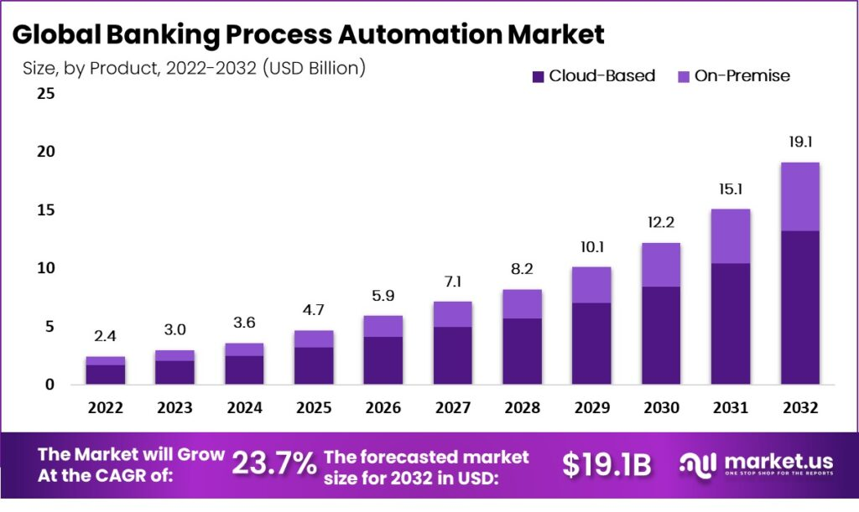
- Younger demographics (18-34 years) utilise voice banking services at a higher rate than older age groups, with 35% utilising them on a regular basis.
Conclusion:
Voice banking services represent a disruptive trend in the financial industry, providing users with exceptional ease and accessibility. While problems like as security, accuracy, and privacy remain, continued technological developments and regulatory compliance are expected to promote additional acceptance and innovation in voice banking services across the US market.
Conclusion:
The convergence of internet, mobile, and voice banking has altered the financial services scene in the United States, providing more ease, efficiency, and security. While these digital solutions increase accessibility and usability, they also introduce security problems, technical obstacles, and the digital divide. As usage increases, financial institutions must solve these difficulties in order to provide a safe and smooth banking experience. The continued growth of digital banking offers even more innovative solutions, hence improving financial management.

